THE MAGNIFICAT
BEFORE PRESENTATION
YouTube Video (played while people are arriving)
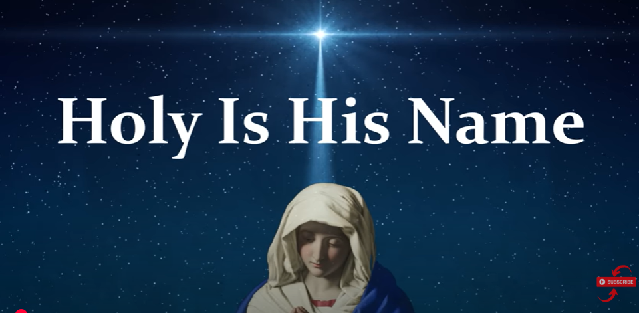
YouTube https://youtu.be/i85XG4OwQ8s?si=gL1bgVdqKOr2DP7x (Stop at 3.45mins)
START OF PRESENTATION
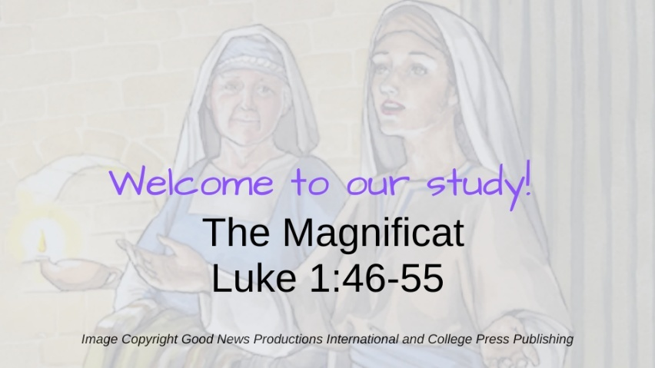
I hope you enjoyed the YouTube video ‘Holy is His Name’ by John Michael Talbot. Welcome to the presentation, looking at ‘the Magnificat’ – known as ‘Mary’s Song’ in Luke 1:46-55. You will have been given handouts containing all the slides we shall be using today along with relevant texts. I have also included references in case you wish to further explore the subject. Let’s start with a prayer.
Reading of Luke 1:46-55
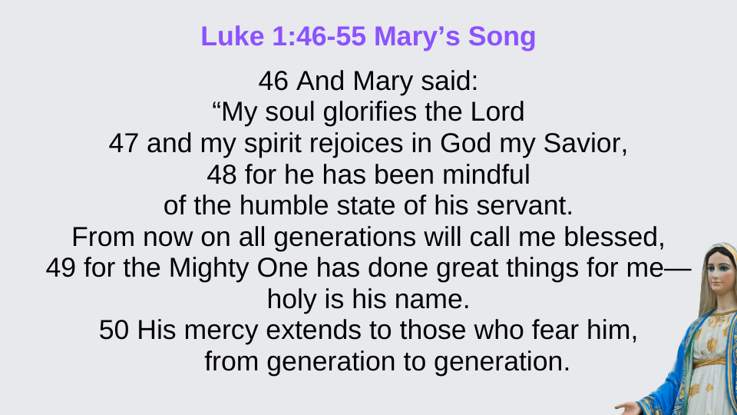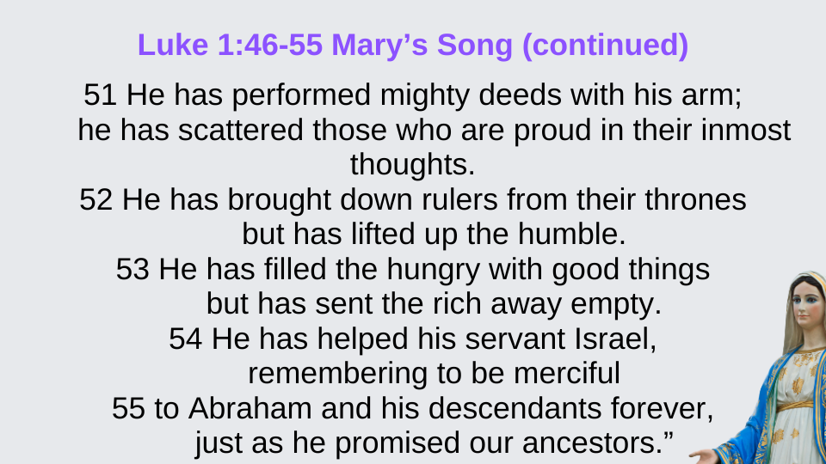
We will now read the text that we will be studying – Luke 1:46-55 - the Magnificat also known as ‘Mary’s Song’. If someone could read it for us that would be great.

Session Outline
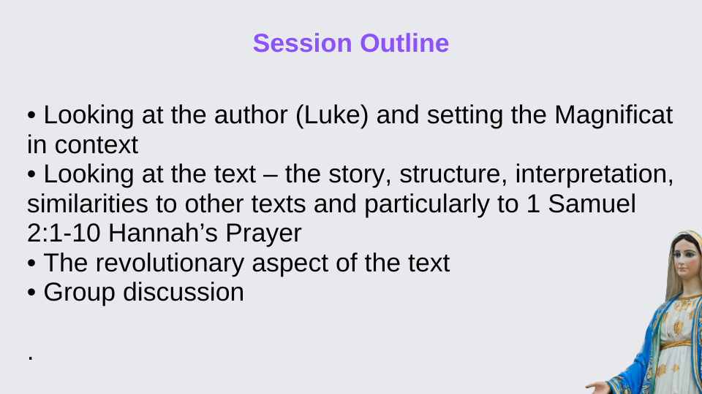
The aim of today is to view the Magnificat theologically, with a follow up session next week where we will look at it in a contemplative manner. This session will cover the authorship and the setting the Magnificat, along with its context in terms of the previous verses. We will look at the text - the story, structure, interpretation, similarities to other texts and particularly similarities to 1 Samuel 2:1-10 Hannah’s Prayer. We will also briefly look at revolutionary aspects of the text and finish with a group discussion
Luke and his Gospel
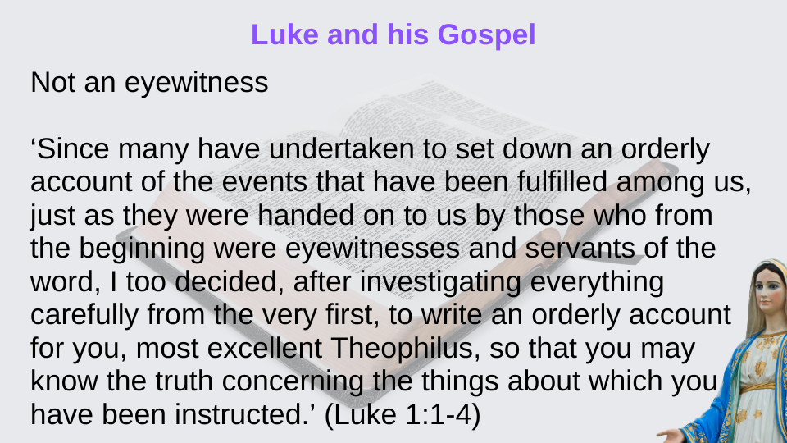
We will start with some background information on the author, Luke. Luke was not considered to be an eyewitness and it is believed he was a physician. We see from Luke 1:1-4 that he in fact had to investigate in order to obtain his own account of Jesus.
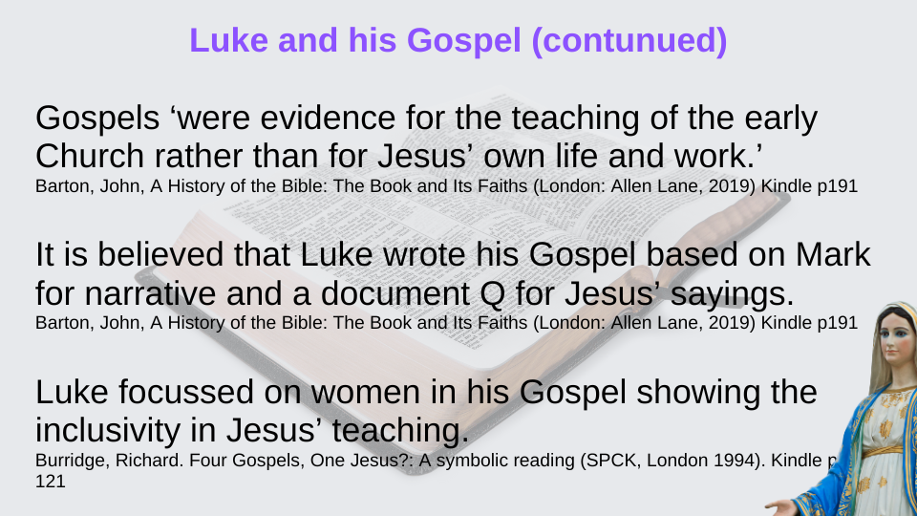
The Gospel of Luke was estimated to have been written in 80/90 CE. Theologian John Barton states that the Gospels are ‘evidence for the teaching of the early Church rather than for Jesus’ own life and work.’ It is believed that Luke wrote his Gospel based on Mark for narrative and a document called Q for Jesus’ sayings. He will of course have added his own personal slant to his writings – aiming his writings at a gentile audience. It is also believed that he accompanied Paul on many occasions and additionally was also the writer of Acts.
We also see Luke focussing on women which shows the inclusivity in Jesus’ teaching as women were of course less acceptable than men. We see many women mentioned by Luke, his concern for widows, and Mary is mentioned by Luke thirteens times by name and refers to her on other occasions.

Setting the Magnificat in Context
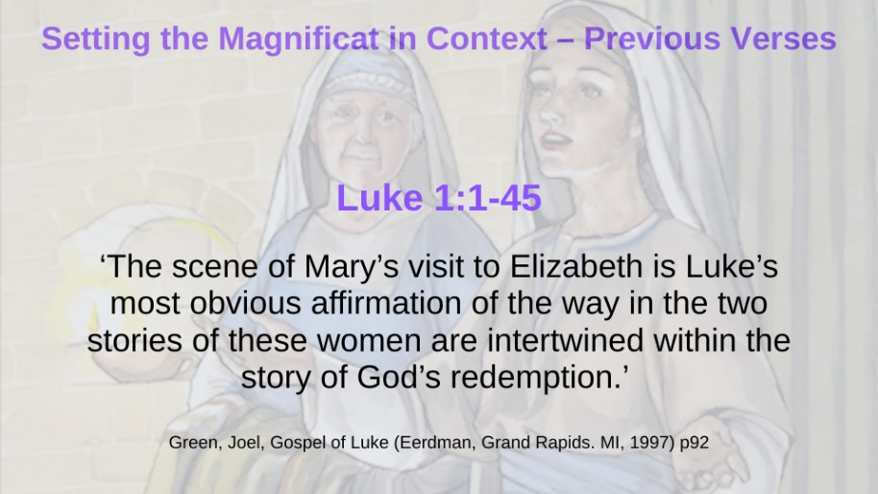
I am sure you are all familiar with this story, however, let’s remind ourselves of the lead up to Mary’s Song in verses 46-55 Luke sets the scene by introducing Zechariah, a descendant of Aaron, and part of the priesthood - along with his wife Elizabeth. Both were elderly and childless as Elizabeth was unable to conceive. However, the angel Gabriel visits Zechariah and promised a child will be born to them. Thus Elizabeth subsequently conceives.
We then see the angel Grabriel visiting Mary
35 …‘The Holy Spirit will come on you, and the power of the Most High will overshadow you. So the holy one to be born will be called the Son of God. 36 Even Elizabeth your relative is going to have a child in her old age, and she who was said to be unable to conceive is in her sixth month. 37 For no word from God will ever fail.’ (Luke 1:35-37)
Mary then visits Elizabeth and we see in verse 41
‘41 When Elizabeth heard Mary’s greeting, the baby leaped in her womb, and Elizabeth was filled with the Holy Spirit. 42 In a loud voice she exclaimed: ‘Blessed are you among women, and blessed is the child you will bear! 43 But why am I so favoured, that the mother of my Lord should come to me? 44 As soon as the sound of your greeting reached my ears, the baby in my womb leaped for joy. 45 Blessed is she who has believed that the Lord would fulfil his promises to her!’ (Luke 1:41-45)
So we see Elizabeth’s baby leaping in her womb in response to hearing Mary, and Elizabeth proclaiming Mary as the mother of the Lord.
About The Magnificat Luke 1:46-55
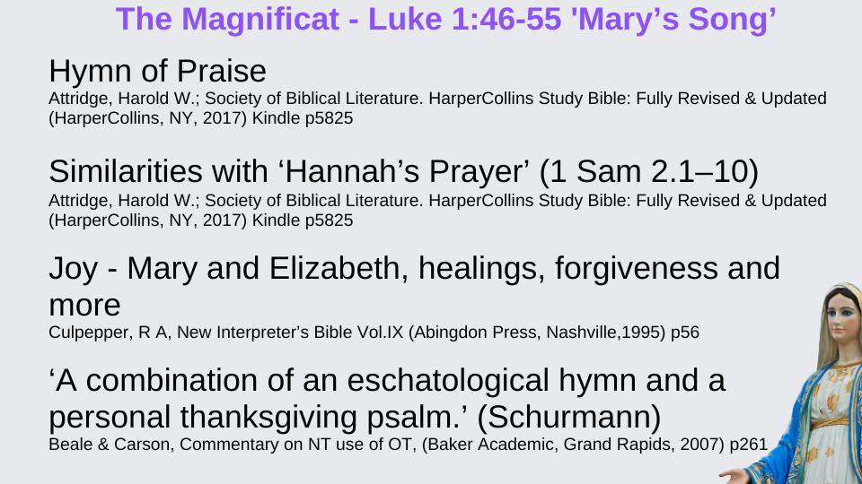
Mary’s Song is a hymn of praise. It has established similarities with ‘Hannah’s Prayer’ (1 Sam 2.1–10), for example in terms of praising God for saving the oppressed and lowly. It also has similarities with other OT texts. We will look at these similarities in terms of Hannah’s Prayer and other OT texts a little later in the presentation.
The Magnificat is full of joy – and we see evidence of joy throughout Luke not only with Mary and Elizabeth, but healings, forgiveness and more.
Schurmann’s states the text as being ‘a combination of an eschatological hymn and a personal thanksgiving psalm.’
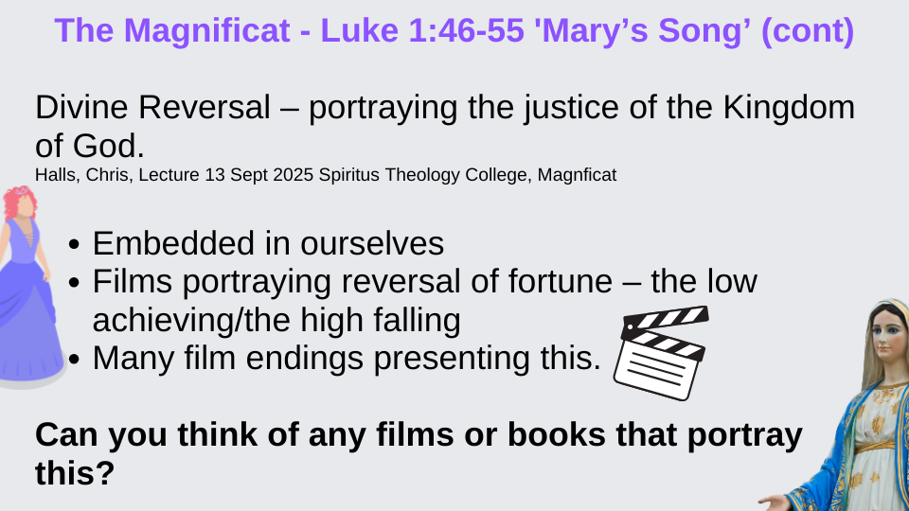
We see divine reversal occurring in the text and also throughout Luke which portrays the justice of the Kingdom of God. This is indeed embedded in ourselves – films portraying reversal of fortune – the low achieve, the unjust high fall. I certainly find this type of story hits me in the heart – what about you?
Can you think of any films or books that portray this?
(Cinderella, Pretty Woman)
Similarities to Verses in the OT
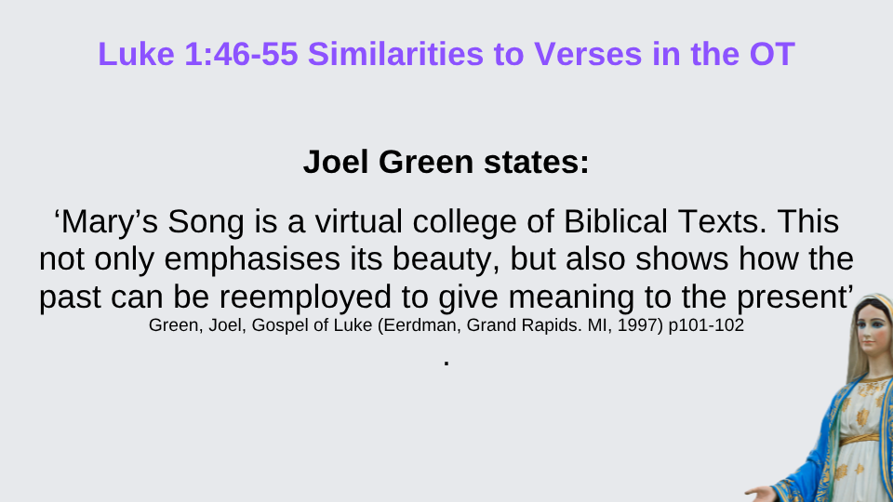
There are many similarities between The Magnificat and other OT texts. Joel Green states ‘Mary’s Song is a virtual college of Biblical Texts. This not only emphasises its beauty, but also shows how the past can be reemployed to give meaning to the present’ And indeed we can see in the following slides, examples of this.
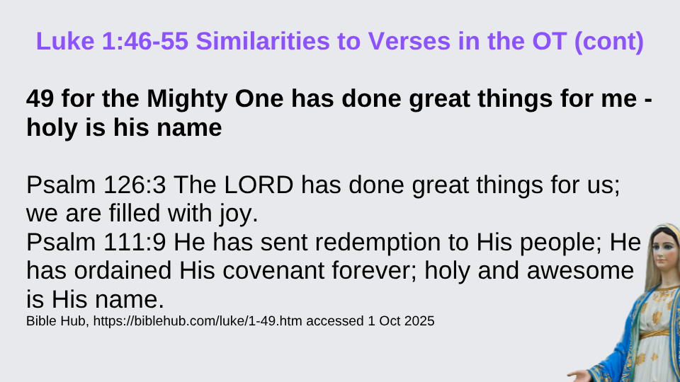
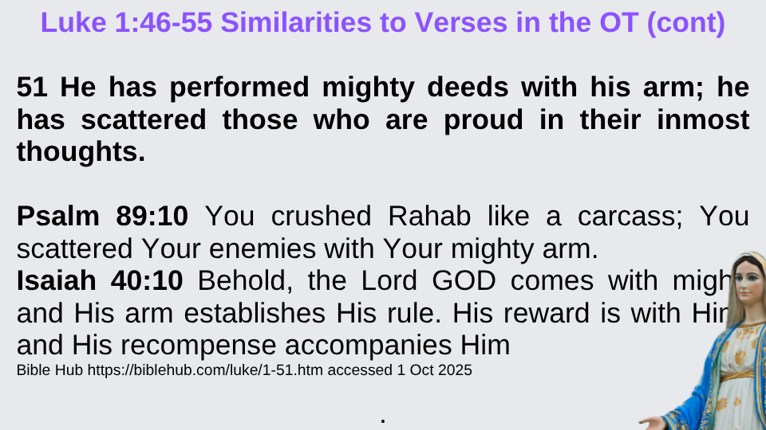
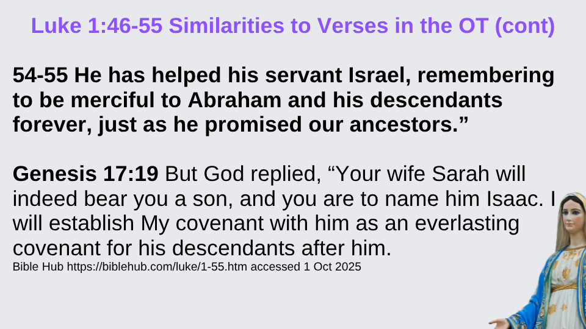

Structure and Role of the Magnificat
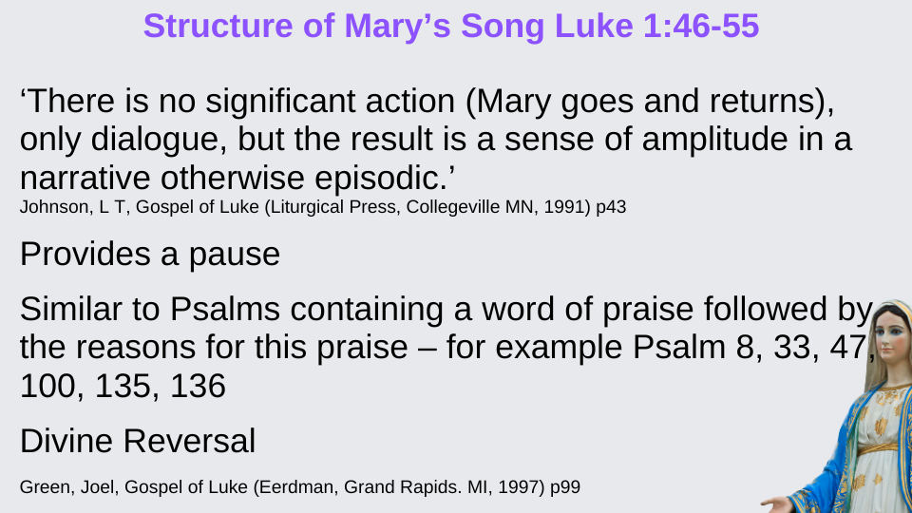
We will now look at the structure and role of the Magnificat. We will start with a quote. In relation to the annunciation accounts, Johnson states ‘There is no significant action (Mary goes and returns), only dialogue, but the result is a sense of amplitude in a narrative otherwise episodic.’ Another way of putting this I believe is the movement in the story belies the action in the story.
We also see the text providing a narrative pause - stopping all movement in the story and providing significance to Mary. Additionally, there is similarity to Psalms that feature a word of praise, which is then followed by the reason for this praise. We also see divine reversal which we looked at previously.
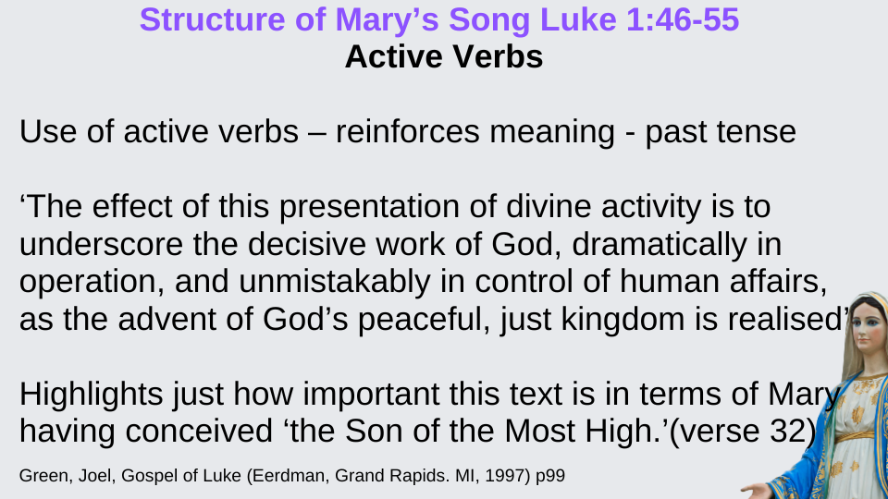
We also see the use of active verbs in the past (aorist) tense, with God as the subject. Aorist is defined as ‘an inflectional form of a verb typically denoting simple occurrence of an action without reference to its completeness, duration, or repetition,’ and we can see this in the text.
Green states:
‘The effect of this presentation of divine activity is to underscore the decisive work of God, dramatically in operation, and unmistakably in control of human affairs, as the advent of God’s peaceful, just kingdom is realised’
Green suggests it was written this way to highlight just how important this text is in terms of Mary having conceived ‘the Son of the Most High.’(verse 32)
Green also points out that whilst the text is generally aoristic, Mary is pregnant now which brings it into the present. Whilst the unveiling of the Kingdom of God is in the future he considers the text is meant for today – and could be seen in terms of foreign occupation, and political and religious oppression. Thus its reputation as being revolutionary.
We also see parallelism which is shown on the following slides.
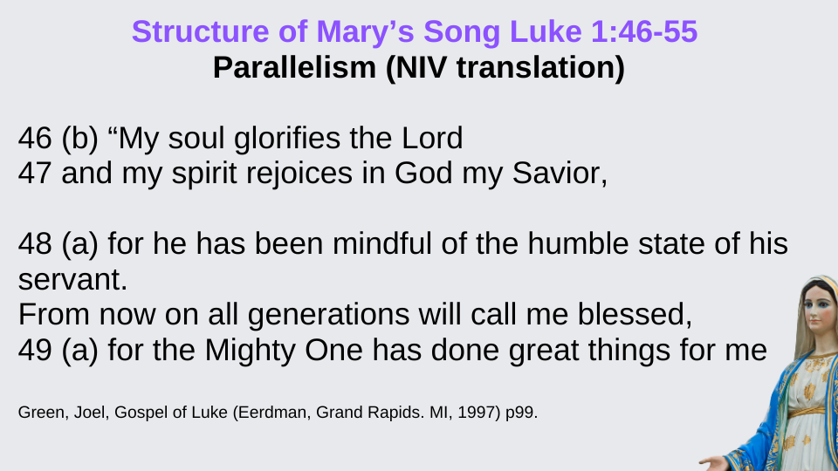
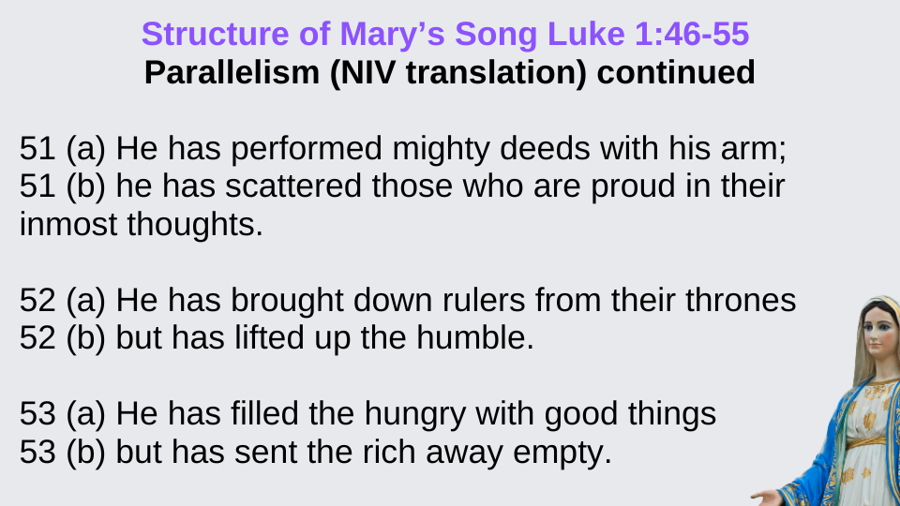
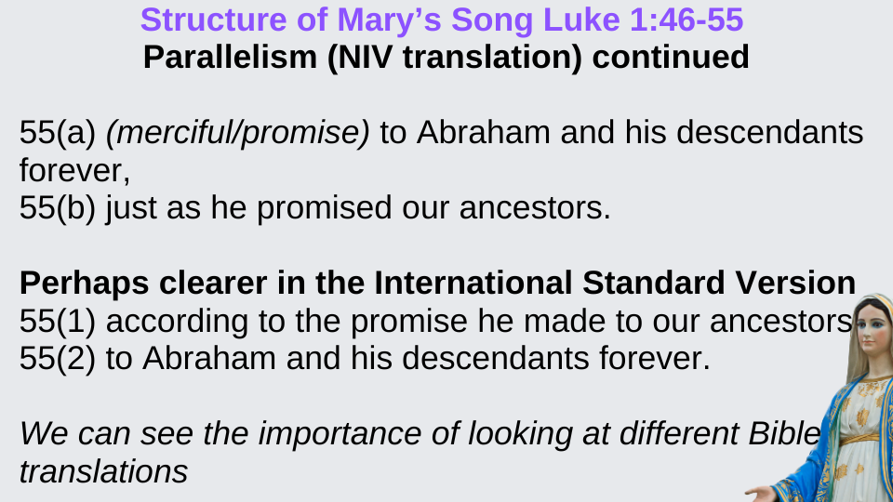
We can see how by weaving complementary lines, that meaning is intensified. Incidentally, we can see what a difference there can be between translations as in verse 55 NIV and 55 ISV.
Comparison to 1 Samuel 2:1-10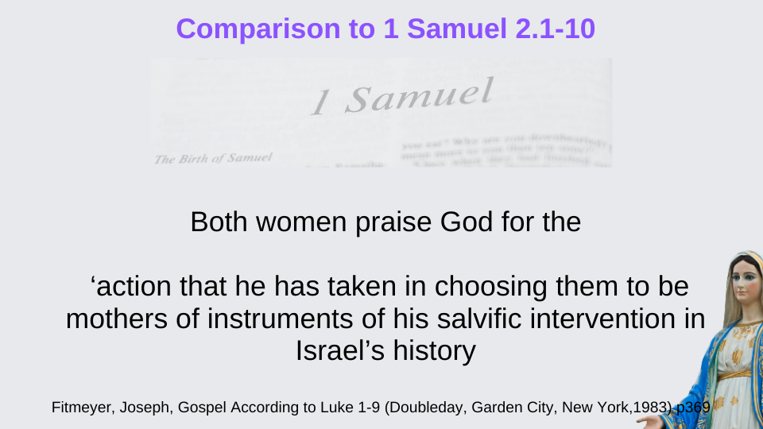
We will now look at the similarities between the Magnificat and Hannah’s Prayer (1 Samuel 2:1-10). Both women praise God for the ‘action that He has taken in choosing them to be mothers of instruments of his salvific intervention in Israel’s history’
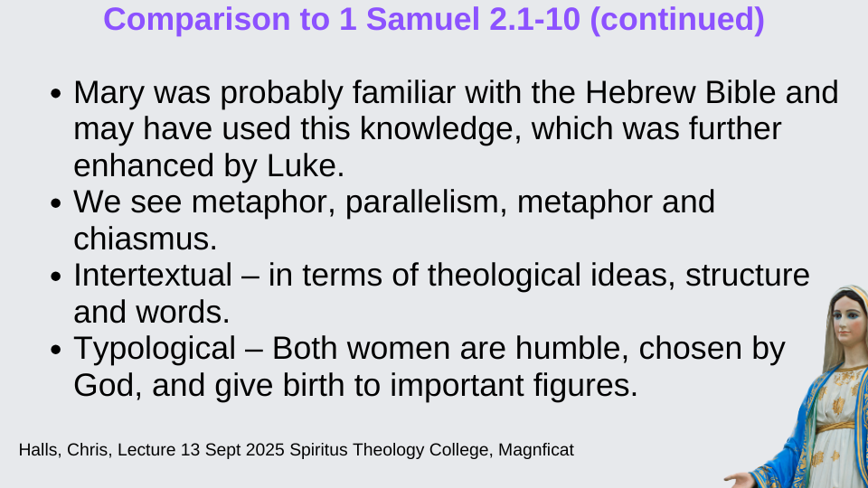
It has been proposed that Mary was probably familiar with the Hebrew Bible and may have used this knowledge, which was further enhanced by Luke – although there are alternative theories. We see metaphor, parallelism, metaphor and chiasmus in both, and similarities in terms of theological ideas, structure and words. Both women are humble, chosen by God, and give birth to important figures.
The following slides will highlight various themes regarding these similarities.
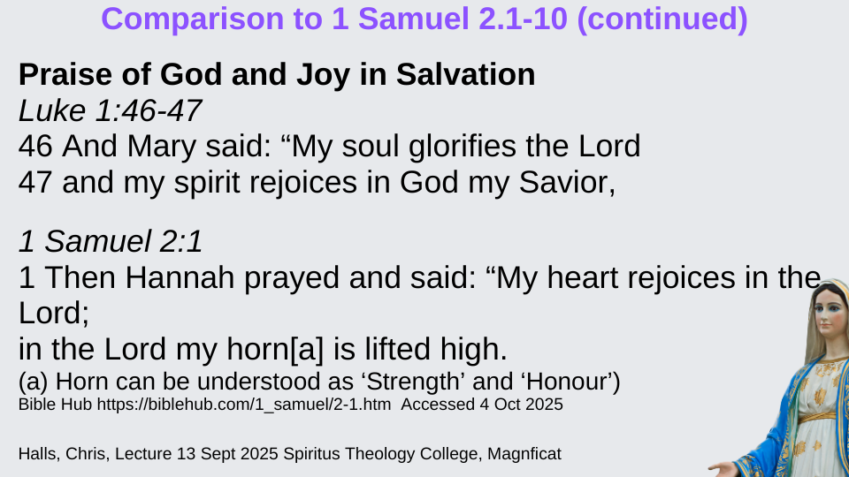
Here we see similarities in terms of the praise of God and joy in Salvation.
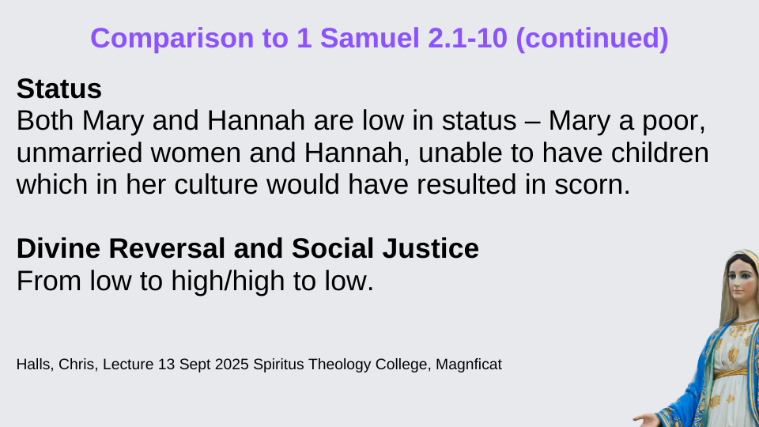
Both Mary and Hannah are low in status – Mary a poor, unmarried women and Hannah, unable to have children which in her culture would have resulted in scorn.
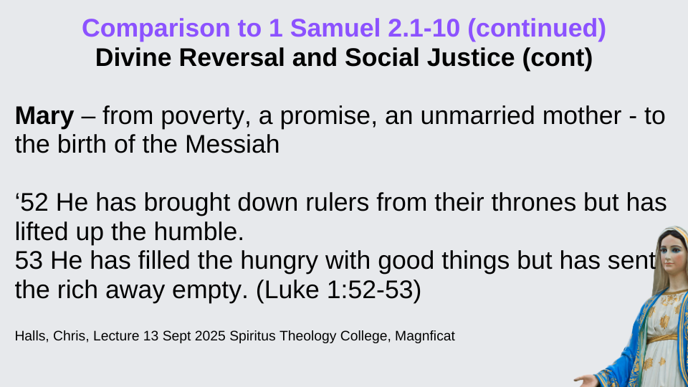
Both feature divine reversal and social justice. Mary – from poverty, receives a promise, becomes an unmarried mother but then gives birth to the Messiah.
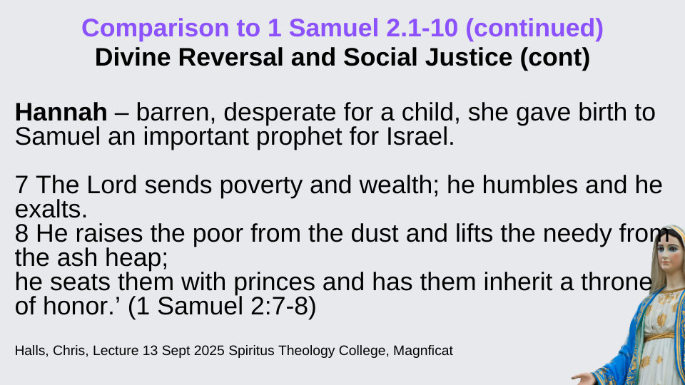
Hannah is barren and desperate for a child yet she gave birth to Samuel an important prophet for Israel.
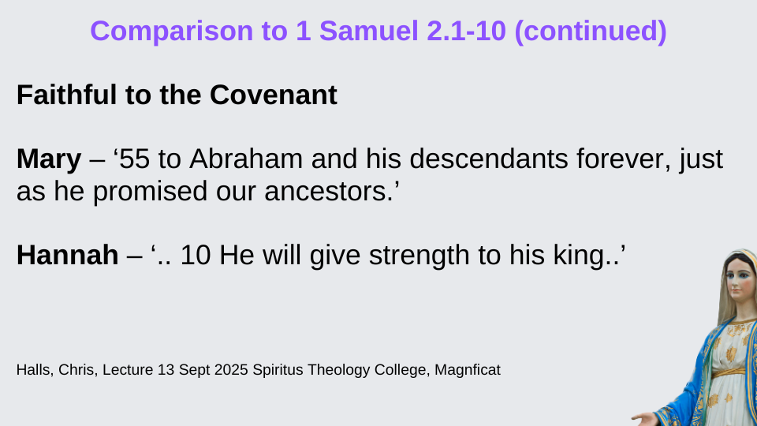
Both feature faithfulness to the Covenant

Revolutionary Aspects
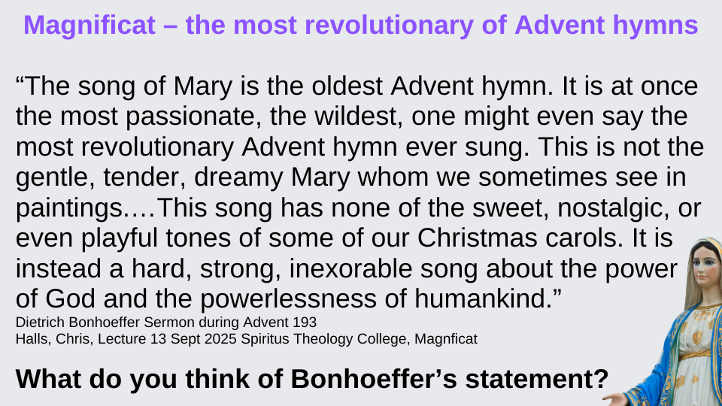
We will now discuss the revolutionary aspects of the text. Dietrich Bonhoeffer in his Sermon during Advent 1933 suggested the Magnificat as the most revolutionary of Advent hymns. In fact it was banned by some political regimes.
“The song of Mary is the oldest Advent hymn. It is at once the most passionate, the wildest, one might even say the most revolutionary Advent hymn ever sung. This is not the gentle, tender, dreamy Mary whom we sometimes see in paintings.…This song has none of the sweet, nostalgic, or even playful tones of some of our Christmas carols. It is instead a hard, strong, inexorable song about the power of God and the powerlessness of humankind.” (Dietrich Bonhoeffer - Sermon during Advent 1933.)
We have seen previously the suggestion by Green that the text could be seen in terms of foreign occupation, and political and religious oppression - which could suggest the text is revolutionary.
However, Green also points to the Magnificat as a ‘celebration of God’s action’ – and in fact rejects those grasping power (verse 52).
What do you think of Bonhoeffer’s statement?
Group Discussion

The concludes the lecture part of the presentation. Now we have a little time if you have any questions or would like to discuss any part of the presentation.
Optional Further Questions (if time allows)
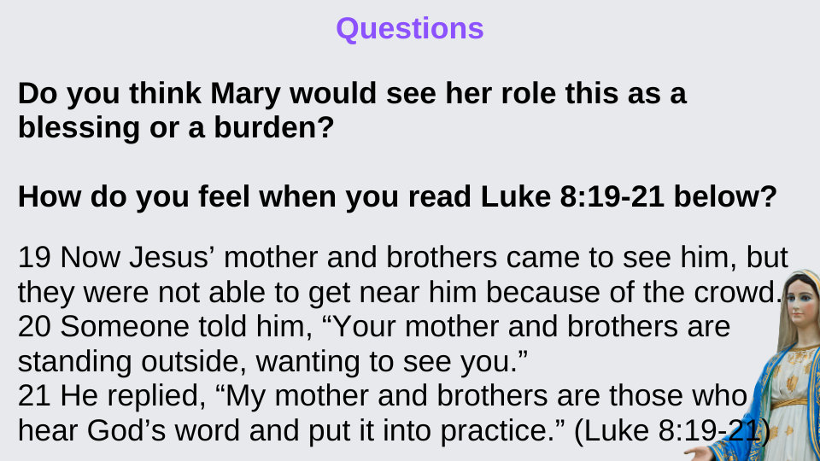
Blessing
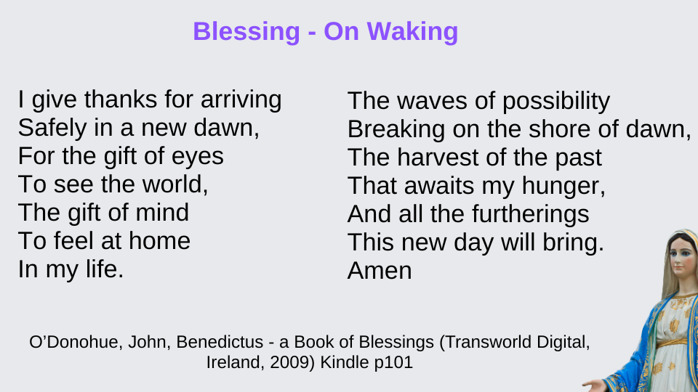
Thank you for attending today and I hope it gave you a different way of looking at the Magnificat. In our next session we will look again at the Magnificat, but this time from the lens of contemplation. We will start with Lectio Divina and follow this with discussion on how you found the different ways of looking at the Magnificat – a more formal orthodox study as we did today and next week’s contemplation method.
We will finish with a blessing which we will say together.
End Slide (as people are leaving)


Handouts and PowerPoint can be downloaded at
https://kareng.co.uk/magnificat-bible-study/
Bibliography
Attridge, Harold W.; Society of Biblical Literature. HarperCollins Study Bible: Fully Revised & Updated (HarperCollins, NY, 2017) Kindle p. 5825
Beale & Carson, Commentary on NT use of OT, (Baker Academic, Grand Rapids, 2007) p261-265
Barton, John, A History of the Bible: The Book and Its Faiths (London: Allen Lane, 2019) Kindle
Bible Hub https://biblehub.com/ Accessed 4 Oct 2025
Burridge, Richard. Four Gospels, One Jesus?: A symbolic reading (SPCK, London 1994). Kindle
Culpepper, R A, New Interpreter’s Bible Vol.IX (Abingdon Press, Nashville,1995) p53-55
Grausso, Christine Marie https://era.ed.ac.uk/handle/1842/37291 accessed 8 October 2025
Goldingay, John, Do We Need the Old Testament? Letting the Old Testament Speak for Itself (Downers Grove, IL: IVP, 2015) Kindle
Green, Joel, Gospel of Luke (Eerdman, Grand Rapids. MI, 1997) p92-105
Halls, Chris, Lecture 13 Sept 2025 Spiritus Theology College, Magnficat CLH SLIDES.pdf/ HANDOUT Magnificat Exegesis 2021.doc
Johnson, L T, Gospel of Luke (Liturgical Press, Collegeville MN, 1991) p40-44
McColman, Carl, The New Big Book of Christian Mysticism: An Essential Guide to Contemplative Spirituality (Broadleaf Books, Minneapolis, 2023) Kindle
Méndez, Hugo, Semitic Poetic Techniques in the Magnificat: Luke 1:46–47, 55, JSTOR, Journal of Biblical Literature, Vol. 135, No. 3 (Fall 2016), pp. 557-574 https://www.jstor.org/stable/10.15699/jbl.1353.2016.2713?seq=1 accessed 8 Oct 2025
Merriam Webster Dictionary, https://www.merriam-webster.com/dictionary/aorist accessed 15 October 2025
Muddiman, John; Barton, John. The Gospels (Oxford Bible Commentary) (OUP Oxford, 2010). Kindle p135 onwards
Muddiman, John; Barton, John. The Oxford Bible Commentary (OUP Oxford, 2007). Hub
Nolland, John, Word Biblical Commentary Luke 1:1-9:20 (Zondervan, Grand Rapids, MI, 2000) p59-77
O’Donohue, John, Benedictus - a Book of Blessings (Transworld Digital, Ireland, 2009) Kindle
Strauss, Mark L, Luke: The Gospel of the Savior for Lost People Everywhere, The Bible Project, https://bibleproject.com/articles/luke-gospels-savior-lost-people/ accessed 13 Oct 2025
Talbot, John Michael. Arr. by Phil Perkins and Rick Modlin, Catholic & Christian Choral Music, Holy Is His Name Magnificat (Birdwing Music / BMG Songs 1995), YouTube https://youtu.be/i85XG4OwQ8s?si=gL1bgVdqKOr2DP7x (Stop at 3.45mins)

Talbot, John Michael. Arr. by Phil Perkins and Rick Modlin, Catholic & Christian Choral Music, Holy Is His Name Magnificat (Birdwing Music / BMG Songs 1995), YouTube https://youtu.be/i85XG4OwQ8s?si=gL1bgVdqKOr2DP7x (Stop at 3.45mins)
Talbot, John Michael. Arr. by Phil Perkins and Rick Modlin, Catholic & Christian Choral Music, Holy Is His Name Magnificat (Birdwing Music / BMG Songs 1995), YouTube https://youtu.be/i85XG4OwQ8s?si=gL1bgVdqKOr2DP7x (Stop at 3.45mins)
Barton, John, A History of the Bible: The Book and Its Faiths (London: Allen Lane, 2019) Kindle p189
Halls, Chris, Lecture 13 Sept 2025 Spiritus Theology College, Magnficat CLH SLIDES.pdf/ HANDOUT Magnificat Exegesis 2021.doc
Barton, John, A History of the Bible: The Book and Its Faiths (London: Allen Lane, 2019) Kindle p191
Barton, John, A History of the Bible: The Book and Its Faiths (London: Allen Lane, 2019) Kindle p191
Strauss, Mark L, Luke: The Gospel of the Savior for Lost People Everywhere, The Bible Project, https://bibleproject.com/articles/luke-gospels-savior-lost-people/ accessed 13 Oct 2025
Burridge, Richard. Four Gospels, One Jesus?: A symbolic reading (SPCK, London 1994). Kindle p120-121
Attridge, Harold W.; Society of Biblical Literature. HarperCollins Study Bible: Fully Revised & Updated (HarperCollins, NY, 2017) Kindle p. 5825
Attridge, Harold W.; Society of Biblical Literature. HarperCollins Study Bible: Fully Revised & Updated (HarperCollins, NY, 2017) Kindle p. 5825
Culpepper, R A, New Interpreter’s Bible Vol.IX (Abingdon Press, Nashville,1995) p56
Beale & Carson, Commentary on NT use of OT, (Baker Academic, Grand Rapids, 2007) p261
Halls, Chris, Lecture 13 Sept 2025 Spiritus Theology College, Magnficat CLH SLIDES.pdf/ HANDOUT Magnificat Exegesis 2021.doc
Green, Joel, Gospel of Luke (Eerdman, Grand Rapids. MI, 1997) p101-102
Bible Hub, https://biblehub.com/luke/1-49.htm accessed 1 Oct 2025
Bible Hub https://biblehub.com/luke/1-51.htm accessed 1 Oct 2025
Bible Hub https://biblehub.com/luke/1-55.htm accessed 1 Oct 2025
Johnson, L T, Gospel of Luke (Liturgical Press, Collegeville MN, 1991) p43
Green, Joel, Gospel of Luke (Eerdman, Grand Rapids. MI, 1997) p98
Green, Joel, Gospel of Luke (Eerdman, Grand Rapids. MI, 1997) p99
Green, Joel, Gospel of Luke (Eerdman, Grand Rapids. MI, 1997) p99
Merriam Webster Dictionary, https://www.merriam-webster.com/dictionary/aorist accessed 15 October 2025
Green, Joel, Gospel of Luke (Eerdman, Grand Rapids. MI, 1997) p99
Green, Joel, Gospel of Luke (Eerdman, Grand Rapids. MI, 1997) p100
Green, Joel, Gospel of Luke (Eerdman, Grand Rapids. MI, 1997) p100
Green, Joel, Gospel of Luke (Eerdman, Grand Rapids. MI, 1997) p99
Fitmeyer, Joseph, Gospel According to Luke 1-9 (Doubleday, Garden City, New York,1983) p369
Halls, Chris, Lecture 13 Sept 2025 Spiritus Theology College, Magnficat CLH SLIDES.pdf/ HANDOUT Magnificat Exegesis 2021.doc
Halls, Chris, Lecture 13 Sept 2025 Spiritus Theology College, Magnficat CLH SLIDES.pdf/ HANDOUT Magnificat Exegesis 2021.doc
Halls, Chris, Lecture 13 Sept 2025 Spiritus Theology College, Magnficat CLH SLIDES.pdf/ HANDOUT Magnificat Exegesis 2021.doc
Halls, Chris, Lecture 13 Sept 2025 Spiritus Theology College, Magnficat CLH SLIDES.pdf/ HANDOUT Magnificat Exegesis 2021.doc
Halls, Chris, Lecture 13 Sept 2025 Spiritus Theology College, Magnficat CLH SLIDES.pdf/ HANDOUT Magnificat Exegesis 2021.doc
Halls, Chris, Lecture 13 Sept 2025 Spiritus Theology College, Magnficat CLH SLIDES.pdf/ HANDOUT Magnificat Exegesis 2021.doc
https://biblehub.com/topical/d/divine_reversal.htm accessed 4 Oct 2025
Halls, Chris, Lecture 13 Sept 2025 Spiritus Theology College, Magnficat CLH SLIDES.pdf/ HANDOUT Magnificat Exegesis 2021.doc
Halls, Chris, Lecture 13 Sept 2025 Spiritus Theology College, Magnficat CLH SLIDES.pdf/ HANDOUT Magnificat Exegesis 2021.doc
Halls, Chris, Lecture 13 Sept 2025 Spiritus Theology College, Magnficat CLH SLIDES.pdf/ HANDOUT Magnificat Exegesis 2021.doc
Green, Joel, Gospel of Luke (Eerdman, Grand Rapids. MI, 1997) p100
Green, Joel, Gospel of Luke (Eerdman, Grand Rapids. MI, 1997) p100

