GROUP LEADER NOTES

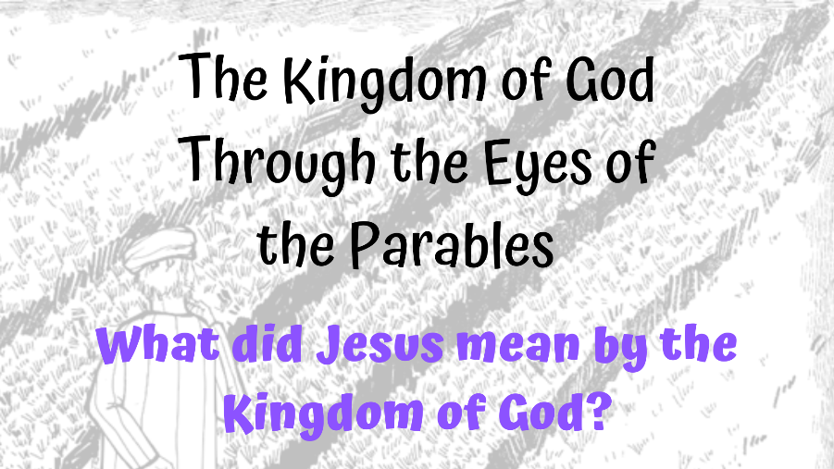

The Kingdom of God Through the Eyes of the Parables - What did Jesus mean by the Kingdom of God?
ABOUT THIS STUDY
This study is intended as an online resource delivered over Zoom and a first step in exploring, sharing and engaging in Bible study and theology. It could be used as a church-based resource or perhaps used with those interested in exploring Christianity. It should be limited to around 10 participants to ensure good engagement in discussions. Group leaders should email the participants the relevant Bible verses prior to each session, and the relevant study text afterwards. All information and downloads are available from. https://kareng.co.uk/parables-bible-study/
SESSION 1
SLIDE 1 (Pin leader screen, Mute Participants, Screen Share)
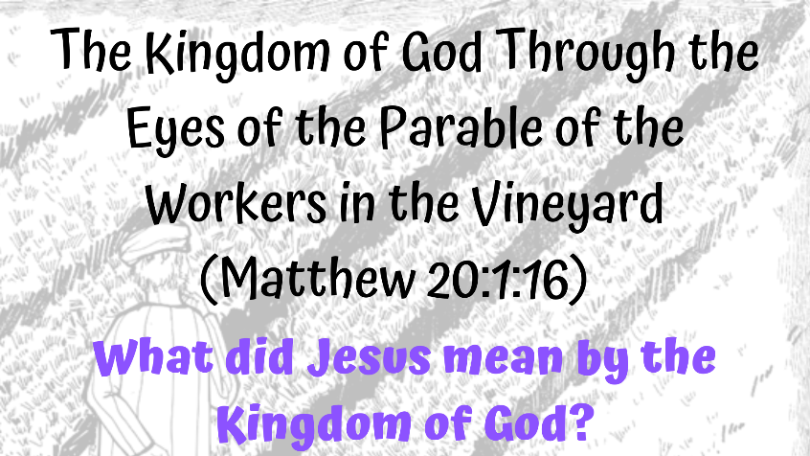
Introduction
Welcome to the study - looking at the Kingdom of God through the eyes of the parables. Firstly, let’s do some housekeeping. This is a safe space, and I would ask that whatever is said in this space stays in this space. You will have noticed I have muted your sound. You will of course be able to unmute yourself when you want to speak.
Finally, relax and enjoy the course!
Course Outline
Parables were aimed at specific aspects of the Kingdom of God, with the main subject of the Parables being ‘The Kingdom of God is like…….’. There are four main themes - the Kingdom and its ruler, its people, the community, and the future.
Let’s open with a prayer
SLIDE 2

(Stop screen share)
Session 1 – The Parable of the Workers in the Vineyard
In this session we will look briefly at the Kingdom of God and parables before focussing on the parable of the workers in the vineyard. We will see what this tells us about the meaning of the Kingdom of God as portrayed by Jesus, and look how we can relate this to today.
So, what is the Kingdom of God?
An extremely brief overview. Whilst in English Kingdom means place, Biblically it means ‘action’ – an activity of a king reigning over people. The theme of the Kingdom of God runs throughout the Bible with the first reference being found in Genesis 1:27-28, when the word rule is used. Rule was the language of kings and suggests humans would rule with God on His behalf. However, the OT shows that despite God’s efforts there is a break down of the relationship, with distrust and humans defining good and evil for themselves. We see Abraham chosen by God and the subsequent escape from captivity in Egypt. God invites his people to live under his rule with the Torah, but the people rebel. Israel decides it wants a king and we see a succession of 40 kings, the majority of whom brought evil and wrongdoing and captivity in Babylon. The poets of the time still believed that God was king of the world and we see particularly the prophet Isaiah foretelling the day when the Kingdom of God will arrive. (Isaiah 52-53).
Jesus brought the good news - the arrival of the kingdom. But the Jewish people were expecting a new earthly, political kingdom to defeat the Romans, bringing peace through violence However, Jesus brings a different type of kingdom – one of love and peace, confronting evil, and reaching out to poor broken people. Ian Mackie from the Bible Project states ‘Jesus becomes the human we were made to be. Through Him we become the humans we were meant to be’ Jesus promoted the kingdom in various ways including parables and we will now watch a video about the parables by the Bible Project
SLIDE 3 (Share screen)

(Parables of Jesus – Bible Project https://youtu.be/XX-aAg4_U2Q)
(Unmute participants, Stop screen share)
We will now go into breakout rooms (of 3 or 4) for 5 minutes so you can introduce yourselves and discuss your favourite parables
Welcome back, Let’s now read the Parable - The Parable of the Workers in the Vineyard Matthew 20:1-16 (NIV)
Can I have two volunteers to read Matthew 20:1-8 and Matthew 20:9-16 please
The words will be on the screen, although you will also have been sent a document containing the text – or of course you could use a Bible!

SLIDE 4 (Screen share)
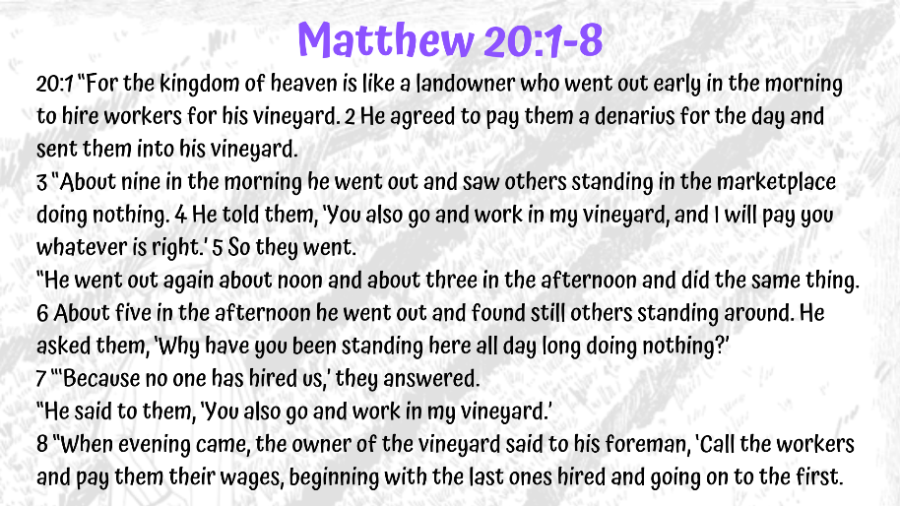
SLIDE 5
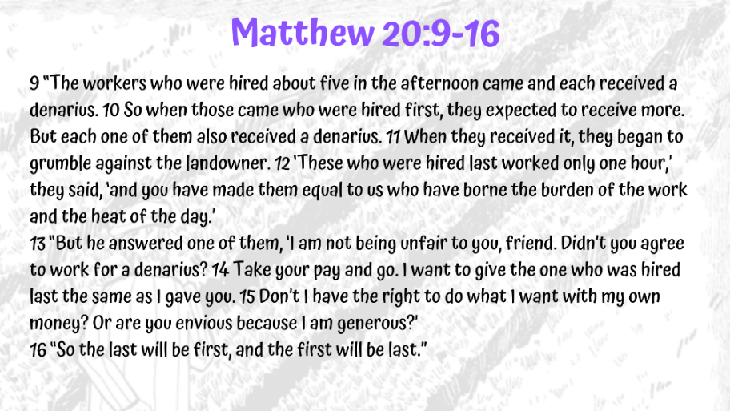
Thank you.
(Mute participants, Stop screen share)
The Workers in the Vineyard and the Kingdom of God
This parable is related to the theme of The Kingdom and its Ruler whereby the Kingdom of God takes its’ character and form from God. The theme portrays generosity and unconditional love. Jesus also challenged the patriarchal structure, challenged male stereotypes, and spoke of relational qualities. Parables of these types look at how the Kingdom of God takes its’ character and form from God. The workers in the vineyard looks at the generosity of God.
The verses preceding the parable set the parable in context (Matthew 19:16-22). We see that the rich man seems to meet the criteria for eternal life, with one exception – he won’t give up his wealth. This causes the disciples to question their own position and question what they need to do to – after all, they have given up everything to follow Jesus. Jesus points to them sitting on twelve thrones and judging the twelve tribes of Israel but warns ‘But many who are first will be last, and many who are last will be first’ (Matthew 19:30) – and of course we see this repeated at the end of the parable itself.
The story is true to the day - the harvest needed to be gathered before the rains came, so extra unskilled workers were hired even if they could only work an hour – meeting in the marketplace. The first to be hired in the early morning are likely to be the fit and able, with the ones left until later being the older labourers and the less able. The first workers agreed to one denarius for a day’s wage whilst the later workers who were engaged at 9am, noon, 3pm and 5pm agreed to accept what the vineyard owner considers right and fair. One denarius was the normal days wage – but a day without pay for these workers would be a day without essential sustenance for their families. Workers had to be paid before the end of the day as referred to by Moses in Leviticus 19:13 and is also mentioned in Deuteronomy 24:15.’
At the end of the day the owner called the foreman to pay all the workers one denarius – and significantly he said to pay the last workers first and the first workers last. Seeing the ‘one hour’ workers receive one denarius, the others expected more. Those who worked all day grumbled but the landowner pointed out their agreement to work all day for one denarius and asked if they were envious of his generosity.
So, what does this parable tell us about what Jesus meant by the Kingdom of God? Barton et al state ‘The divine grace will blow where it wills’ It certainly alludes to eternal life and salvation. All who believe will be accepted into the Kingdom of God – not dependent upon works, piety, or sacrifice. All will be treated equally. In the parable, all got what they were promised. We see that those who worked all day were more than happy to work for one denarius, until they realised that other workers had worked less hours for the same amount.
SLIDE 6 (Unmute participants, Screen share)
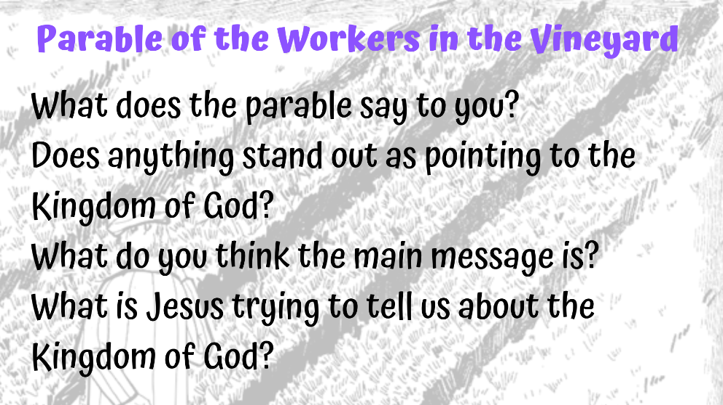
We will go into breakout rooms for 5 minutes and then discuss the questions on screen as a group (15 mins). I will also put these questions into the chat.
(Unpin leader screen, Stop screen share)
(Pin leader screen)
Thank you. We have seen the parable in the context of Jesus’ time – could we perhaps relate this to present day? A change of perspective resulted in the workers being jealous rather than joyfully receiving what they had been promised. How often are we guilty of this? Are we not guilty of being jealous of others who have more? The disciples were perhaps believing they would receive special benefits. John MacArthur compares the disciples to the ‘all day’ workers in the parable. Are we the same? Do we consider ourselves more worthy in the eyes of God if we do more work for our church?

SLIDE 7 (Screen share)
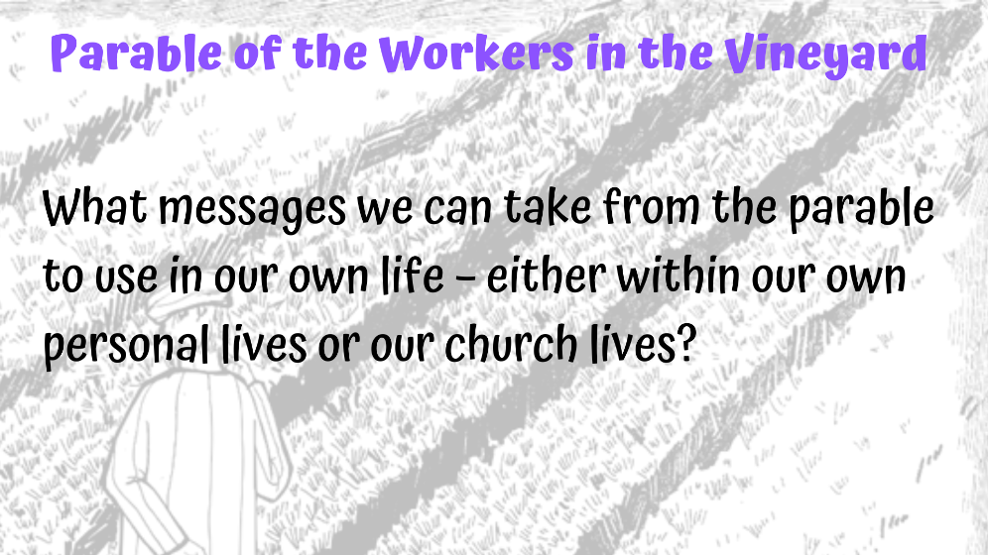
As a group we will now discuss what messages we can take from the parable to use in our own life – either within our own personal lives or our church lives? (Unpin leader screen, Stop screen share) (15 minutes group discussion)
(Pin leader screen)
Thank you all for your valuable contribution and I hope you have enjoyed this session. Here is a little task for you to do between at home. This is not compulsory so don’t feel you have to do it.
SLIDE 8 (Screen share)

What I would like you to do is to re-write the parable in a present day setting and email it to me.
Let’s close with a prayer
SLIDE 9

(Unpin leader screen, Stop screen share)
Timing – 15 minutes leader talking/readings, 5 minutes parable video, 40 minutes breakout rooms/group discussion = Total time 1 hour
EXTRA NOTES TO REFER TO DURING DISCUSSION
The Kingdom of God
For many the concept of kingdom, and God as king was familiar. We see this in Psalms 99:1, 96:10, 146:10, ‘The Lord reigns, let the nations tremble; he sits enthroned between the cherubim, let the earth shake’ (Psalm 99:1). Eventually ‘king’ was merged between a human leader and God – starting with David and subsequent kings. This concept, based on God choosing the leader/king to rule on his behalf did not work out, and ‘disappeared under the pressure of political expediency.’
However, there was still hope for a true Messiah bringing in a Kingdom of justice. Zechariah 14:9 states ‘the Lord will become king over all the earth’. But what sort of kingdom would this be? The expectation was a political, earthly Messiah to defeat the Romans - peace through violence. It was with this expectation that Jesus arrived declaring ‘the time is fulfilled, and the kingdom of God is at hand (Mark 1:15). Of course Jesus’ kingdom was not one of violence – rather one of achievement through peace, love, and worshiping God above all else.
N.T Wright considers the polarisation of churches today in that they are either ‘kingdom’ or ‘cross’ churches with the former focusing on the teaching of Jesus and the latter on the cross. Wright brings this together by stating ‘Gospels are the story of how God’s son inaugurated God’s kingdom through his work and death’
Parables
Parables were considered as allegories until in the 19c Julicher proposed that they were ‘intended as an illustration to make a particular point’. Thus parables were then seen as stories with one main point – with remaining details providing background .
There is debate as to why Jesus used this method. Barclay considers it was easier to walk away in the open air compared to synagogues – thus Jesus needed to engage his audience. Additionally, the audience was familiar with parables in the OT for example 2 Samuel 12:1–7, and Rabbis taught using this method. Barclay describes parables beautifully as ‘Something on earth is compared with something in heaven, that the heavenly truth may be better grasped in light of the earthly illustration.’ Parables have four main themes with Jesus saying ‘the kingdom of God is like….’ either its ruler, its people, the community, or the future. The parable of the workers in the vineyard is included in the theme of the kingdom and its ruler, portraying God’s generosity. Drane points out that all communities are shaped by their ruler, with Jesus using encouragement and stories rather than military authoritarianism.
Parable of the Workers in the Vineyard
For context the preceding verses are important (Matthew 19:16-30). We see the rich man denied the promise of eternal life as he would not give up his riches – and the disciples wrongly assuming it is through God’s favour that wealth is obtained. However, money itself is not the problem, but rather priorities – that is, worshiping money more than God. We see in Matthew 22:36-38 ‘“Teacher, which is the greatest commandment in the Law?” Jesus replied: “‘Love the Lord your God with all your heart and with all your soul and with all your mind.’ This is the first and greatest commandment.’ This can be related back to the OT with Moses’ declaration in Deuteronomy 6:4-5 “Hear, O Israel: The Lord our God, the Lord is one! You shall love the Lord your God with all your heart, with all your soul, and with all your strength’.
The disciples question the criteria for entering God’s Kingdom. Matthew 19:27-30 sees Peter asking about himself as he has given his all to Jesus. Whilst Jesus is encouraging, he does allude to the danger of the first becoming last. Verse 28 can be seen to refer to Daniel 7:9-27 in terms of the future Kingdom being based on lordship and points to the authority of the disciples in the future, most likely in the church. We also see a reference to Amidah in terms of restoring the judges. Barton et al consider the parable relates to eschatological reversal at the last judgement and a ‘warning against boasting or presuming oneself to be among the first.’
So what does this parable tell us about Jesus’ meaning of the Kingdom of God? It certainly alludes to eternal life and salvation. All who believe will be accepted into the Kingdom of God – not dependent upon works, piety or sacrifice - and treated equally. In the parable, all got what they were promised – either one denarius or whatever the landowner considered right. We see that those who worked all day were happy to work for one denarius until the time of payment. A change of perspective resulted in jealousy rather than joyfully receiving what had been promised. How often are we guilty of being jealous of others who have more? MacArthur states the parable is about abundant eternal life with Heaven not a reward to be earned, but rather a gracious gift. We see Peter’s eventual understanding of this in Acts 10:34 ‘Then Peter began to speak: “I now realize how true it is that God does not show favouritism’. MacArthur sees the landowner as God seeking and initiating salvation, and using the poor and meek - the poor in spirit - to do this.
The meaning of the Kingdom of God in terms of present day personal and church life
Parables are timeless. We see Peter asking what they will have (Matthew19:27). Barclay states the parable is a warning to the disciples that even though they have followed Jesus from the beginning, all are equal in the eyes of God. We can perhaps see this in churches of today – how do long-term members treat newcomers? Barclay also considers the spirit in which we work. The later workers were happy to work for what the master thought fair, thus we should work to serve God and others with joy and love – not for our own reward. We can see an example of this with the receipt of an expensive gift from a wealthy friend compared to the joy of a small inexpensive gift saved up for by a child. Barclay states “It is the paradox of the Christian life that those who aim at reward lose it, and those who forget reward find it’ John MacArthur compares the disciples to the ‘all day’ workers in the parable. Are we the same? Do we consider ourselves more worthy in the eyes of God if we do more work for our church? Perhaps we do, but we shouldn’t! All believers are equal in the eyes of God and will inherit the same.
Bibliography
Barclay, William. Insights: Parables . (Hymns Ancient and Modern Ltd. 2011) Kindle Edition.
Barton J (Ed), Muddiman J (Ed), The Oxford Bible Commentary (Oxford University Press, Oxford, 2007)
Bibles, Harper. NRSV Bible with the Apocrypha. Zondervan. Kindle Edition.
Bible Project Podcast https://bibleproject.com/podcast/kingdom-god-part-1/ accessed 4 April 2022
Bible Project Podcast https://bibleproject.com/podcast/kingdom-god-part-2/ accessed 4 April 2022
Bible Project Podcast https://bibleproject.com/podcast/kingdom-god-part-3/ accessed 4 April 2022
Bible Project, Parables of Jesus, https://youtu.be/XX-aAg4_U2Q accessed 3 April 2022
Drane, John, Introducing the New Testament, Third Edition, (Lion Hudson, Oxford 2010)
Holy Bible, NIV New International Version, ( Hodder & Stoughton 2011) Kindle Edition.
MacArthur, John,The Mysteries of God’s Kingdom Revealed Through the Stories Jesus Told (Thomas Nelson 2015) Audible
Mackie, Tim, Jesus and the Kingdom of God [Matthew] - Tim Mackie (The Bible Project), https://youtu.be/yACigFnNKwg accessed 28 March 2022
Wright, N.T, Jesus and the People of God https://youtu.be/1AukgNlAgiI accessed 22 March 2022

Drane, John, Introducing the New Testament, p95
Bible Project Podcast https://bibleproject.com/podcast/kingdom-god-part-1/ accessed 4 April 2022
Bible Project Podcast https://bibleproject.com/podcast/kingdom-god-part-2/ accessed 4 April 2022
Drane, John, Introducing the New Testament, p67
Bible Project Podcast https://bibleproject.com/podcast/kingdom-god-part-3/ accessed 4 April 2022
Bible Project Podcast https://bibleproject.com/podcast/kingdom-god-part-2/
Bible Project, Parables of Jesus, https://youtu.be/XX-aAg4_U2Q accessed 3 April 2022
Drane, John, Introducing the New Testament, p95-97
MacArthur, John,The Mysteries of God’s Kingdom Revealed Through the Stories Jesus Told (Thomas Nelson 2015) Audible, chapter 5
Barclay, William. Insights: Parables, Location 780
MacArthur, John,The Mysteries of God’s Kingdom Revealed Through the Stories Jesus Told. chapter 5
Barton J (Ed), Muddiman J (Ed), The Oxford Bible Commentary, p870
MacArthur, John,The Mysteries of God’s Kingdom Revealed Through the Stories Jesus Told Audible, Chapter 4
MacArthur, John,The Mysteries of God’s Kingdom Revealed Through the Stories Jesus Told (Thomas Nelson 2015) Audible, Chapter 4
Drane, John, Introducing the New Testament, p66
Drane, John, Introducing the New Testament, p67
Drane, John, Introducing the New Testament, p68
Drane, John, Introducing the New Testament, p67
Wright, N.T, Jesus and the People of God https://youtu.be/1AukgNlAgiI accessed 22 March 2022
Drane, John, Introducing the New Testament, p90
Drane, John, Introducing the New Testament, p90
Barclay, William. Insights: Parables, location 125-154
Barclay, William. Insights: Parables, location 118
Drane, John, Introducing the New Testament, p95-99
Drane, John, Introducing the New Testament, p95
Barton J (Ed), Muddiman J (Ed), The Oxford Bible Commentary (Oxford University Press, Oxford, 2007) p870
Barton J (Ed), Muddiman J (Ed), The Oxford Bible Commentary, p870
Barton J (Ed), Muddiman J (Ed), The Oxford Bible Commentary, p870
Barton J (Ed), Muddiman J (Ed), The Oxford Bible Commentary, p870
MacArthur, John, The Mysteries of God’s Kingdom Revealed Through the Stories Jesus Told (Thomas Nelson 2015) Audible, Chapter 4
Barclay, William. Insights: Parables, location 787-795
Barclay, William. Insights: Parables, location 826
Barclay, William. Insights: Parables, location 838
MacArthur, John,The Mysteries of God’s Kingdom Revealed Through the Stories Jesus Told Audible, Chapter 4

